**IOT COMMUNICATION**

**MODEL FOR**

**CONNECTING DEVICES**

From batch-7

Experiment-10

Cps lab

**ABOUT IOT COMMUNICATION MODEL :**

* IOT devices are found everywhere and will enable circulatory intelligence in the future. For operational perception, it is important and useful to understand how various IoT devices communicate with each other. Communication models used in IoT have great value. The IoTs allow people and things to be connected any time, any space, with anything and anyone, using any network and any service.
* The ability of IoT devices to communicate back and forth across the network through several protocols and technologies is critical for the success of an IoT deployment. Today, there are many communication technologies available, including:

1. [RFID](https://www.airtel.in/blog/airtel-thanks-app/everything-you-need-to-know-about-fastag/)
2. Ethernet
3. Wi-Fi
4. VHF/UHF/SHF radio
5. Bluetooth
6. DSL
7. Fiber
8. IPv4 and IPv6
9. Etc….

Networks go hand in hand with connectivity, and some popular networks being used in IoT are:

* Local Area Networks (LAN)
* Wide Area Networks (WAN)
* The Internet
* Power Line Communication (PLC)
* Mesh networks
* WIMAX networks
* [Satellite networks](https://www.airtel.in/business/b2b/satellite-internet-solutions)
* Cellular/mobile networks

**AIM**: Build an IoT communication model for connecting device

**Hardware components**:

* Raspberry pi
* Dht11
* Relay
* Jumper wires
* Bulb
* Adaptor

**Software components:**

* Raspberry pi imager
* Putty configuration
* VNC viewer
* Rasp controller

Description:

Communication models used in IoT have great value. The IoTs allow people and things to be connected any time, any space, with anything and anyone, using any network and any service.

Being an IoT bidirectional communication model, this model combines full dual communication between client and server. The connection does not change and remains open until the client submits a request to close the connection. The server has a record of all open communication. It is an entire country communication model, and the server is capable of all open communication.

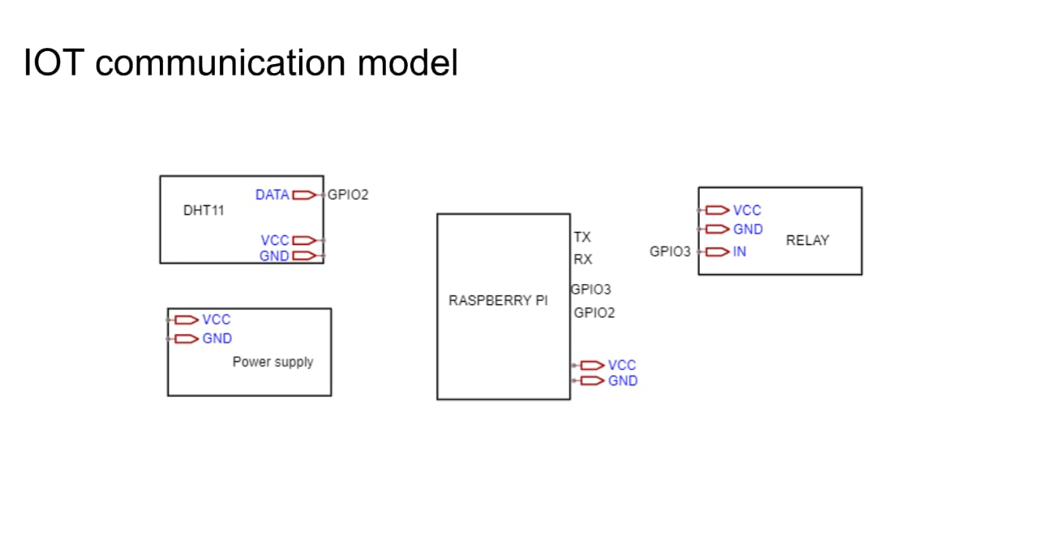

**BLOCK DIAGRAM**

**CIRCUIT DIAGRAM:**

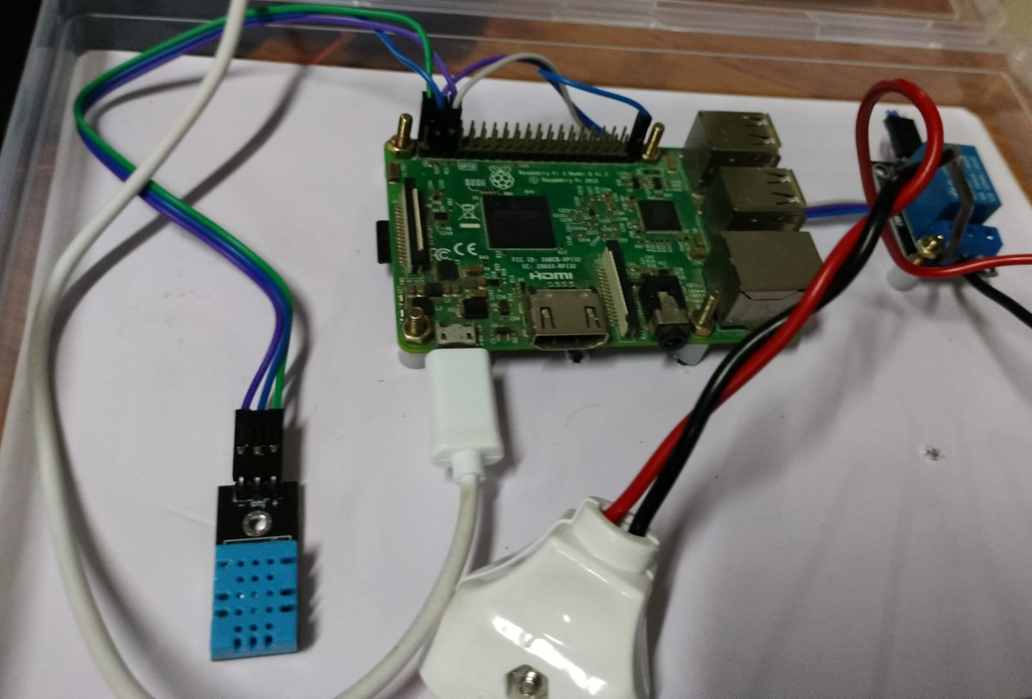

**Procedure**:

1. First we need to insert 16gb sd card into the card reader (usb).Connect that usb to the personal computers.
2. After inserting the usb to the system install the latest os to the usb by using raspberry pi application.
3. Now connect the same user hotspot to the pc and the raspberry pi and note the ip address.
4. In the raspberry pi application select the operating system and install the raspberry pi os (32-bit) online downloader and then select the storage.
5. Then the settings option will be enabled .now open the settings option set the hostname as raspberry pi and enable the SSH and select the use password authentication next set the username as pi and password as raspberry pi and set configure wireless LAN by giving ssid as IOTLAB and password as IOTLAB@123 and finally enable local settings and save it.
6. After changing the settings write option enables then a pop up message occurs select the yes option then write and verifying process will be completed.
7. Then place the memory card to the raspberry pi board.

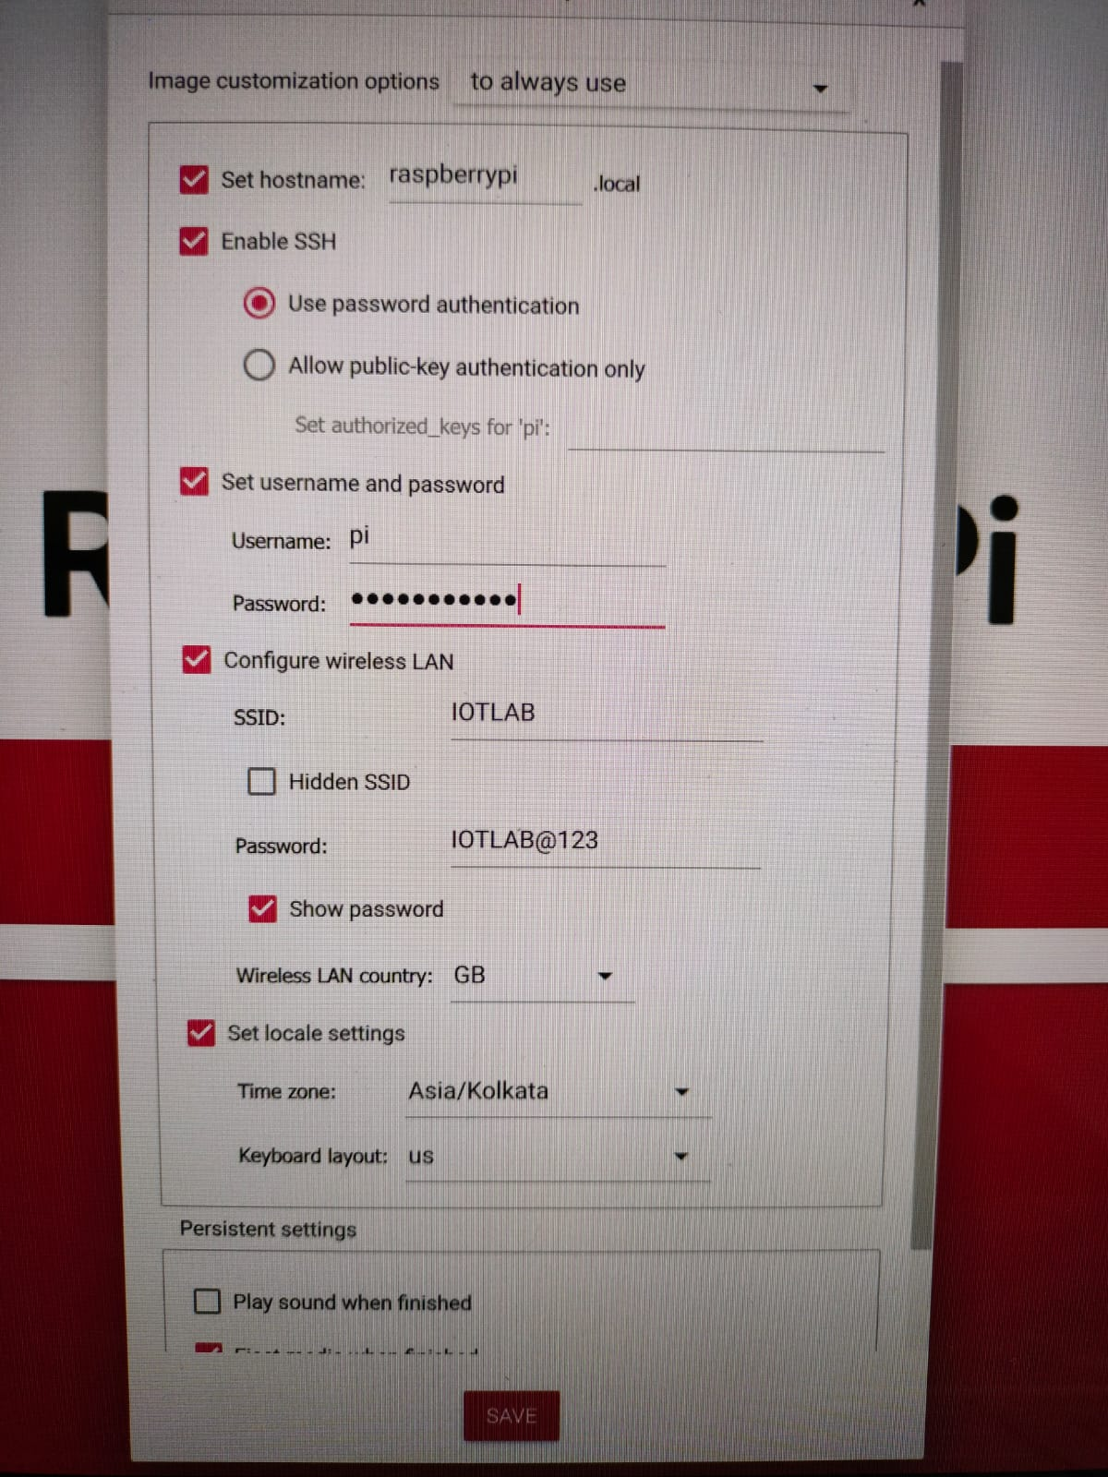

1. After the write option enables we need to enable the vnc viewer we need to login in fthe putty configuration software.
2. In the putty software we need to enter IP address, user name and password.

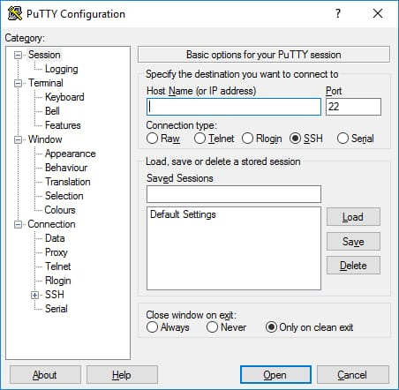

1. Then terminal window opens in the putty software and write a command as “ sudo raspi-config”

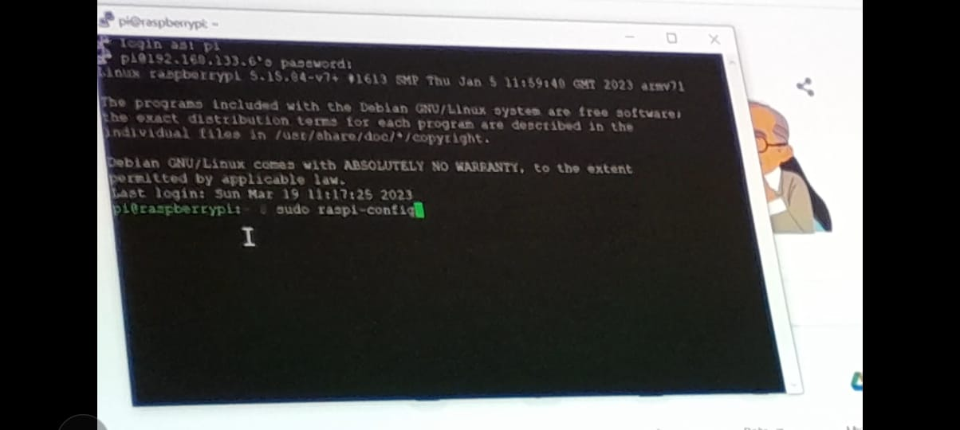

After entering the command a boot window appears in that window go to the interface options and then go to the vnc option and click on enable it.

1. After enabling the vnc viewer a pop up message appears click yes and home page pop ups then choose the finish option . then the vnc viewer enables
2. Now download the vnc viewer software for the desktop window.
3. In the vnc viewer enter the ip address as 192.168.243.6 then pop up window appears where we have to enter the username and password.
4. After the credentials it connects and dashboard will appear.
5. And then install the rasp controller app in the mobile phone after installing the app click on add devices and the add the credentials –

device name as raspberry pi

host/ip address as 192.168.243.6

username as pi

password as raspberrypiand connect the test.

1. After connecting choose the tab dht11 sensor humidity and temperature and then set the gpio config and refresh it

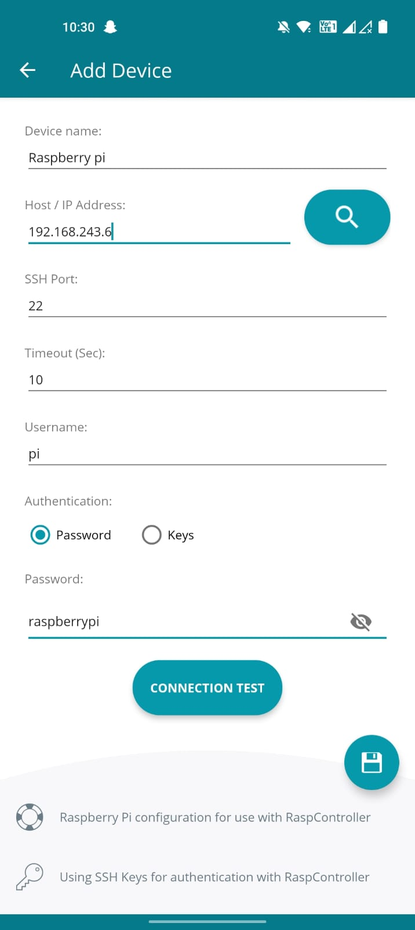

1. And insert the 16gb sd card to the raspberry pi circuit with connecting the dht11,bulb and a adaptor to it.
2. Connect this circuit to device (mobile phone)and then we will operate the circuit function with the device for the output
3. Here we check the temperature and humidity levels by holding the dht11 sensor and on and off conditions with a bulb.

**Output :**

**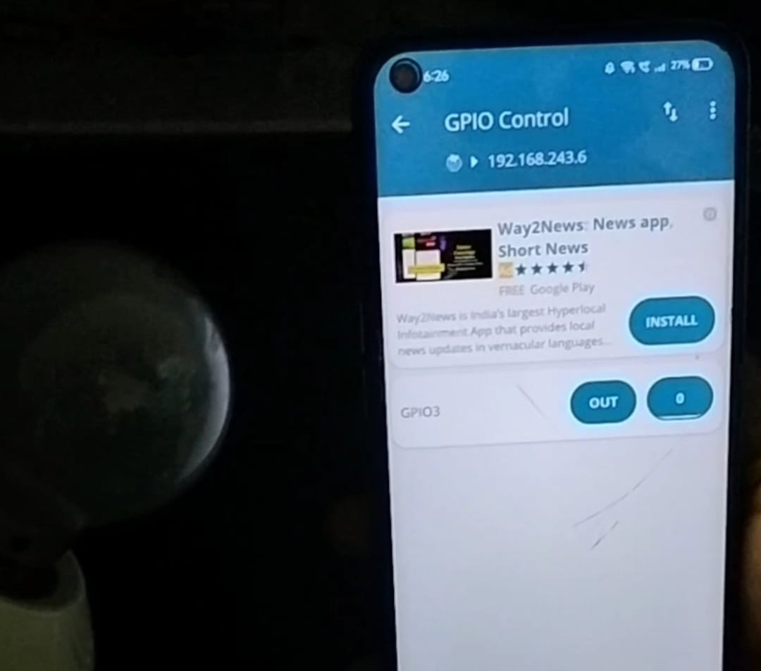 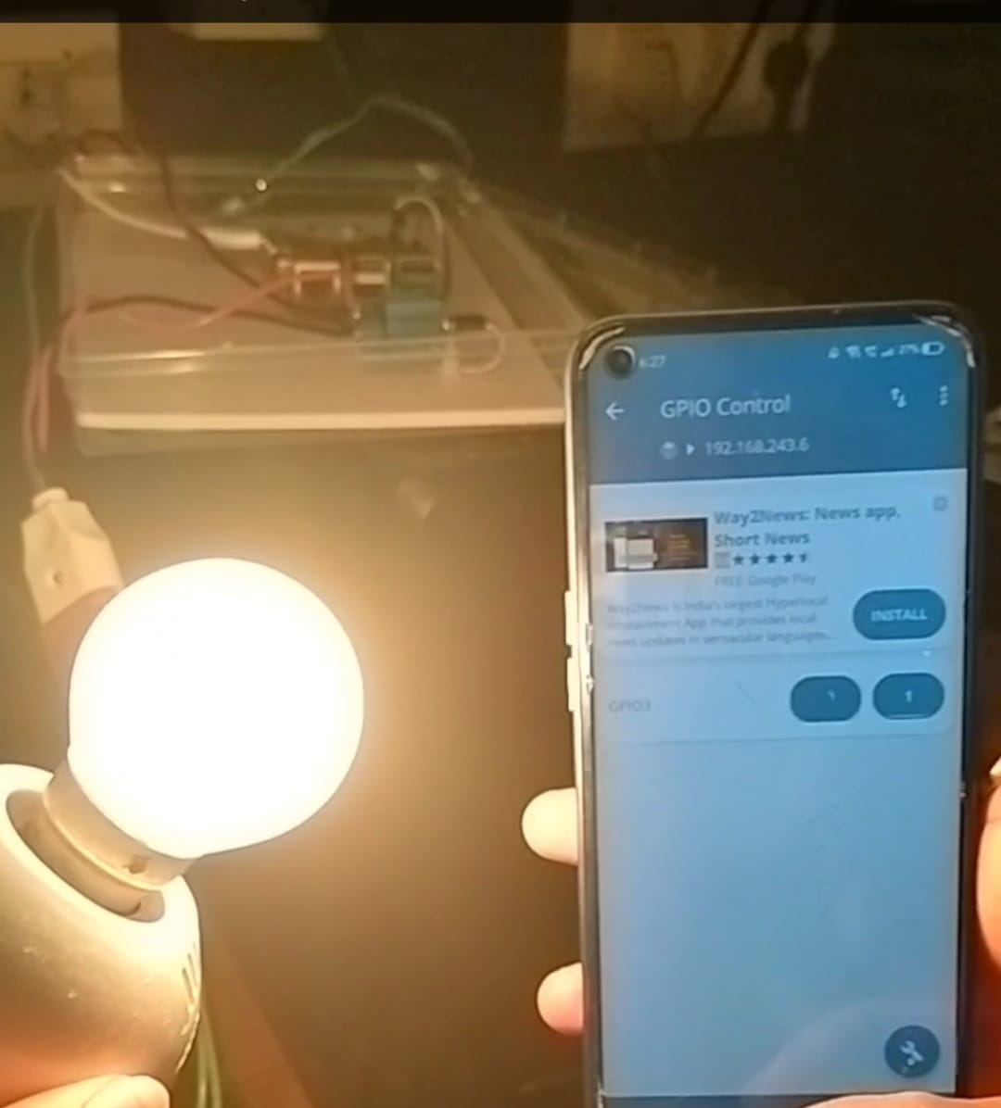  
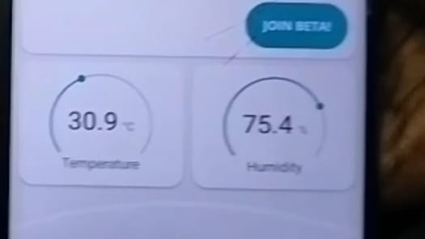**

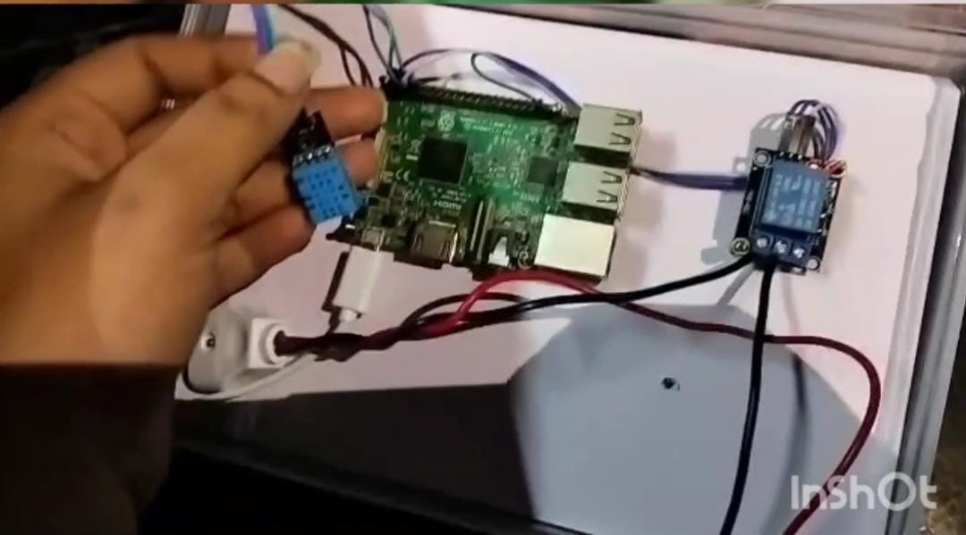

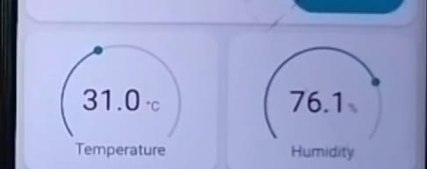

**Conclusion : building and iot communication model for connecting devices is done successfully**